|  |  |
| --- | --- |
| Role position | Quality/Test Engineer - Testing Standard - Junior |
| Location | Frankfurt am Main |
| Number of fte | N/A |
| Rgs id | N/A |
| Remote onsite | Remote with onsite in Germany |
| Onsite frequency week | N/A |
| Project duration | N/A |
| Working hours per day | N/A |
| Contract mode | N/A |
| Daily rate | N/A |
| Language proficiency | German |
| Start date of engagement | N/A |
| Experience required | Experience in conception and execution of software system tests, knowledge of test tools like Jira with Zephyr |
| Must | Experience in conception and execution of software system tests, Knowledge of test tools like Jira with Zephyr |
| Target | Knowledge of Unit Tests and Integration Tests, Experience in testing enterprise applications with heterogeneous systems, Knowledge in testing IT projects at railway companies |

# Framework Agreement CoMPass IT

Domain 1  
Quality/Test Engineering - Testing Standard -  
Junior  
Project: Implementation TAP TSI at DB Regio  
(Existing Project)

# 1 Description of Project/Procedure Context

The European Union defines the requirements for the development of interoperable telematics applications in freight and passenger transport (TAF and TAP) for all railway stakeholders (rail infrastructure companies, railway undertakings, freight forwarders, wagon owners, etc.) across Europe with the technical specifications for interoperability (TSI). The corresponding EU regulations, 1305/2014 (TAF TSI) and 454/2011 (TAP TSI), include, among other things, the requirements and standards for registering and offering train paths as well as the exchange of operational messages concerning trains. The operational messages between railway undertakings (EVU) and infrastructure managers (EIU) listed in TAP-TSI are partially mandatory for both parties. The new format for train path registration is mandatory. The project prioritizes the implementation of the new TAP TSI messages in the system for train path ordering and in the dispatch system for operational messages.

# 2 Subject of the Contract

Within the framework of the project described in section 1, the service provider is responsible for the design, execution, and automation of software tests. The service provider is particularly responsible for creating test cases and independently testing the preliminary or final version of the software referred to in section 1, provided through the contact person. The service provider independently and self-organizedly performs the following services: " Test planning o Identification of test cases o Design, planning of manual and automated component, integration, system, acceptance, or approval tests Checking requirements for their testability, creating test cases from identified test objects, and developing test scenarios o Documentation · Test execution o Creation of test cases o Execution of manual and automated software tests o Evaluation of test results and their documentation o Design, planning, organization, implementation, execution, and documentation of manual and automated component, integration, system, acceptance, or approval tests Checking requirements for their testability, creating test cases from identified test objects, and developing test scenarios (also applies above for automation) Further specification of the service to be provided by the client is permissible, provided the respective service contents are already mentioned in abstract form in the service description, and is carried out through the previously specifically named contact persons. An exchange or addition of the subject matter of the service is only permissible if a corresponding contract amendment or supplement is agreed upon between the parties. Neither the client nor the contractor has the right to unilaterally assign other or additional tasks.

The service provider performs the services independently and on their own responsibility. In carrying out their activities, the service provider is not subject to instructions from the client. Job-related specifications necessary for proper contract execution and compliance with project-related time requirements do not count as instructions in the aforementioned sense. In the event of poor performance by a person employed by the service provider, this person can be rejected by the client.   
Place of performance (or project location):  
The service is generally provided independently of location and remotely. The place of performance (project location) is Frankfurt am Main. The project is planned to be delivered onshore.  
In principle, there must be a willingness to attend appointments that require presence at the appointment location. On-site appointments (Onsite) generally take place in Germany. The project location will be the preferred location for the appointment, but other locations in Germany are also possible.  
The distribution of service delivery between remote (e.g., from the contractor's location) and onsite (or at the client's project location) is visible in the request tool (e.g., easIT).

# Documentation language is German for all committee documents and all sprint content

Coordination with the client and other stakeholders of DB is carried out using technical tools such as MS Teams, telephone, and email, while adhering to the communication structure. The communication tools are agreed upon by the client and contractor at the start of service delivery.

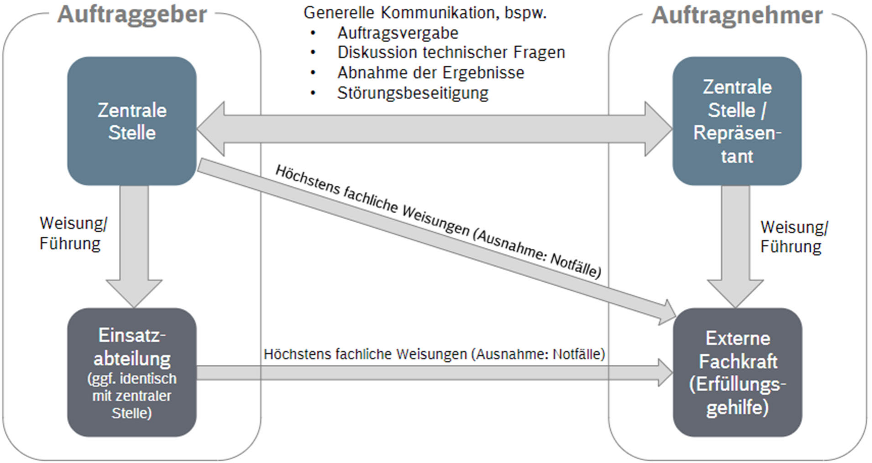

# 5 Follow-up Questions

Follow-up questions regarding the contents of the inquiry can be submitted via the "question option" in the inquiry tool (or easIT). Questions and answers are visible to all framework contract partners, so please pay attention to the "anonymity" of the follow-up questions.

# 6 Other Provisions

In addition, the provisions of the respective valid framework agreement and its annexes of Deutsche Bahn AG, or the respective ordering company with the respective framework contract partner, apply in full.